**Drives and Mechanisms**

**SERVO MOTORS AND STEPPER MOTORS**

1.SERVO MOTORS

Servomotors are special electromechanical devices that produce precise degrees of rotation. A servo motor is a DC or AC or brushless DC motor combined with a position sensing device. Servomotors are also called control motors as they are involved in controlling a mechanical system. The servomotors are used in a closed-loop servo system as shown in Figure 4.2.4. A reference input is sent to the servo amplifier, which controls the speed of the servomotor. A feedback device is mounted on the machine, which is either an encoder or resolver. This device changes mechanical motion into electrical signals and is used as a feedback. This feedback is sent to the error detector , which compares the actual operation with that of the reference input. If there is an error, that error is fed directly to the amplifier, which will be used to make necessary corrections in control action. In many servo systems, both velocity and position are monitored. Servomotors provide accurate speed, torque, and have ability of direction control.

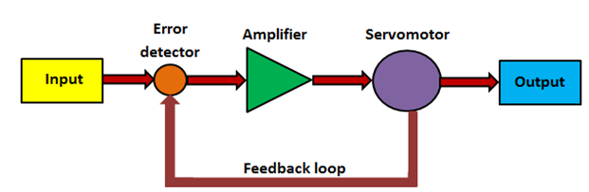

**Fig. 4.2.4 Servo system block diagram**

**DC servomotors**

DC operated servomotors are usually respond to error signal abruptly and accelerate the load quickly. A DC servo motor is actually an assembly of four separate components, namely:

* DC motor
* gear assembly
* position-sensing device
* control circuit

**AC servo motor**

In this type of motor, the magnetic force is generated by a permanent magnet and current which further produce the torque. It has no brushes so there is little noise/vibration. This motor provides high precision control with the help of high resolution encoder. The stator is composed of a core and a winding. The rotor part comprises of shaft, rotor core and a permanent magnet.

Digital encoder can be of optical or magnetic type. It gives digital signals, which are in proportion of rotation of the shaft. The details about optical encoder have already discussed in Lecture 3 of Module 2.

***Advantages of servo motors***

* Provides high intermittent torque, high torque to inertia ratio, and high speeds
* Work well for velocity control
* Available in all sizes
* Quiet in operation
* Smoother rotation at lower speeds

***Disadvantages of servo motors***

* More expensive than stepper motors
* Require tuning of control loop parameters
* Not suitable for ha zardous environments or in vacuum
* Excessive current can result in partial demagnetization of DC type servo motor

ssssmotors

Servo Motors Using Arduino

Because servo motors use feedback to determine the position of the shaft, you can control that position very precisely. As a result, servo motors are used to control the position of objects, rotate objects, move legs, arms or hands of robots, move sensors etc. with high precision. Servo motors are small in size, and because they have built-in circuitry to control their movement, they can be connected [directly to an Arduino](https://www.teachmemicro.com/arduino-tutorials/arduino-servo-tutorial/).

Most servo motors have the following three connections:

* Black/Brown ground wire.
* Red power wire (around 5V).
* Yellow or White PWM wire.

In this experiment, we will connect the power and ground pins directly to the Arduino 5V and GND pins. The PWM input will be connected to one of the Arduino's digital output pins.

CODE:

Here I Am writing code to rotate the servomotor from 0 degrees to 180 degree

#include<servo.h>

servo myservo;

Int pos=0;

void setup()

{myservo.attach(9);

}

void loop()

{for(pos=0;pos<=180;pos+=1)

{myservo.write(pos);

delay(15);

}

for(pos=180;pos>=1;pos--)

{myservo.write(pos);

delay(15);

}

}

2. **Stepper motors**

A stepper motor is a pulse-driven motor that changes the angular position of the rotor in steps. Due to this nature of a stepper motor, it is widely used in low cost, open loop position control systems.

Types of stepper motors:

* Permanent Magnet
  + Employ permanent magnet
  + Low speed, relatively high torque
* Variable Reluctance
  + Does not have permanent magnet
  + Low torque

**1.**  **Variable Reluctance Motor**

Figure 4.2.1 shows the construction of Variable Reluctance motor. The cylindrical rotor is made of soft steel and has four poles as shown in Fig.4.2.1. It has four rotor teeth, 90⁰ apart and six stator poles, 60⁰ apart. Electromagnetic field is produced by activating the stator coils in sequence. It attracts the metal rotor. When the windings are energized in a reoccurring sequence of 2, 3, 1, and so on, the motor will rotate in a 30⁰ step angle. In the non-energized condition, there is no magnetic flux in the air gap, as the stator is an electromagnet and the rotor is a piece of soft iron; hence, there is no detent torque. This type of stepper motor is called a variable reluctance stepper.

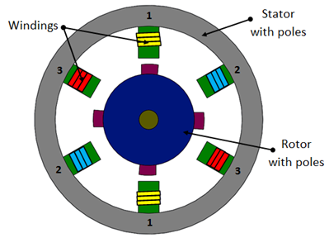

**Fig. 4.2.1 Variable reluctance stepper motor**

**2.   Permanent magnet (PM) stepper motor**

In this type of motor, the rotor is a permanent magnet. Unlike the other stepping motors, the PM motor rotor has no teeth and is designed to be magnetized at a right angle to its axis. Figure 4.2.2 shows a simple, 90⁰ PM motor with four phases (A-D). Applying current to each phase in sequence will cause the rotor to rotate by adjusting to the changing magnetic fields. Although it operates at fairly low speed, the PM motor has a relatively high torque characteristic. These are low cost motors with typical step angle ranging between 7.5⁰ to 15⁰ .

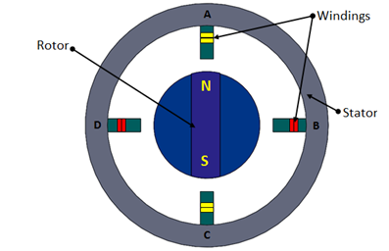

**Fig. 4.2.2 Permanent magnet stepper**

**3.** **Hybrid stepper motor**

Hybrid stepping motors combine a permanent magnet and a rotor with metal teeth to provide features of the variable reluctance and permanent magnet motors together. The number of rotor pole pairs is equal to the number of teeth on one of the rotor's parts. The hybrid motor stator has teeth creating more poles than the main poles windings (Fig. 4.2.3).

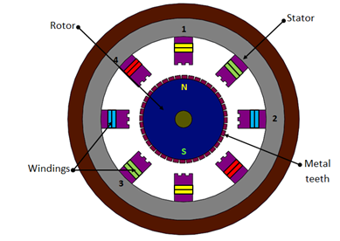

**Fig. 4.2.3 Hybrid stepper**

Rotation of a hybrid stepping motor is produced in the similar fashion as a permanent magnet stepping motor, by energizing individual windings in a positive or negative direction. When a winding is energized, north and south poles are created, depending on the polarity of the current flowing. These generated poles attract the permanent poles of the rotor and also the finer metal teeth present on rotor. The rotor moves one step to align the offset magnetized rotor teeth to the corresponding energized windings. Hybrid motors are more expensive than motors with permanent magnets, but they use smaller steps, have greater torque and maximum speed.

Step angle of a stepper motor is given by,

|  |  |
| --- | --- |
| http://nptel.ac.in/courses/112103174/module4/lec2/images/4.png | (4.2.1) |

**Advantages of stepper motors :**

* Low cost
* Ruggedness
* Simplicity of construction
* Low maintenance
* Less likely to stall or slip
* Will work in any environment
* Excellent start-stop and reversing responses

**Disadvantages of stepper motors :**

* Low torque capacity compared to DC motors
* Limited speed
* During overloading, the synchronization will be broken. Vibration and noise occur when running at high speed.

**CODE:**

#include<stepper.h>

Const int stepsperrevolution=90;

Stepper myStepper(stepsperrevolution(8,9,10,11);

void setup()

{mystepper.setSpeed(5)

Serial.begin(9600);

}

void loop()

{serial.println(“clockwise”);

mystepper.step(stepsperrevolution);

delay(500);

serial.println(“counterclockwise”);

mystepper.step(stepsperrevolution);

delay(500);